Incident Response Report

Subject:
Premium House Lights Inc. Data Breach

Robert Ajegbo
Lighthouse Labs Cyber Security June 26 Cohort
Bootcamp Final Project

Executive Summary:
In February 2022, it was confirmed that we had suffered a significant data breach here at Premium House Lights (PHL). The attackers, only known as the 4C484C Group, gained unauthorized access via the internet to the online web server. They did this by using brute force techniques to eventually establish a handshake and gain remote access. After they had successfully gained access, the hackers were able to move laterally through the network with relative ease. There is a clear lack of effective network segmentation on our network and as a result of this major flaw in the layout, they quickly gained unauthorized access to the PHL database which holds the personally identifiable information (PII) of all of the customers. The intruders copied and stole the database containing this private data, which could now result in serious consequences for the customers. Below, I have attached a screen capture from the extortion email containing the customer data. You can see in another screen capture below that the data matches our customer database table.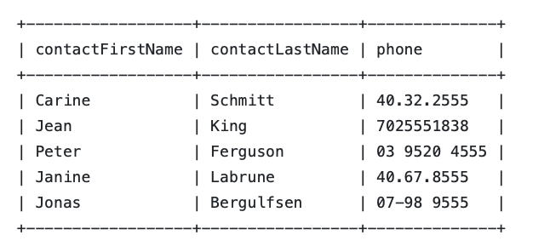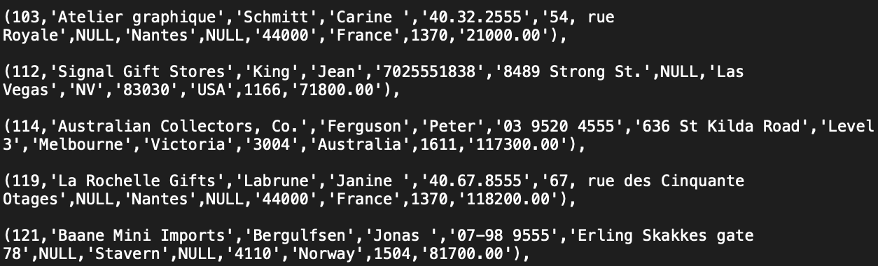

Incident Timeline:
Timestamp | Event | MITRE ATT&CK Tactic
February 19, 2022  21:56:11 to 21:57:40 | Attackers used SiteCheckerBotCrawler to collect data about web pages | Reconnaissance
February 19, 2022  21:58:40 | Trying to run malicious code on the PHL server | Execution
February 19, 2022  21:59:04 | Three-way handshake established between adversary and server | Reconnaissance
February 19, 2022  22:00:27 | Gained access to the PHL Database | Lateral Movement
February 19, 2022  22:00:55 | SQL Injection | Discovery
February 19, 2022  22:01:45 | Hackers successfully exfiltrate copy of the database including private information of customers | Exfiltration

Technical Analysis:
Artifacts Hash Verification:
Before beginning our analysis, we must verify the integrity of the artifacts to ensure that they were not tampered with. I used a standard hash verification command in the Windows command line to confirm the files’ integrity. As you can see in the screen captures below, all of the hash values match up so we can assume that they are safe to analyze.
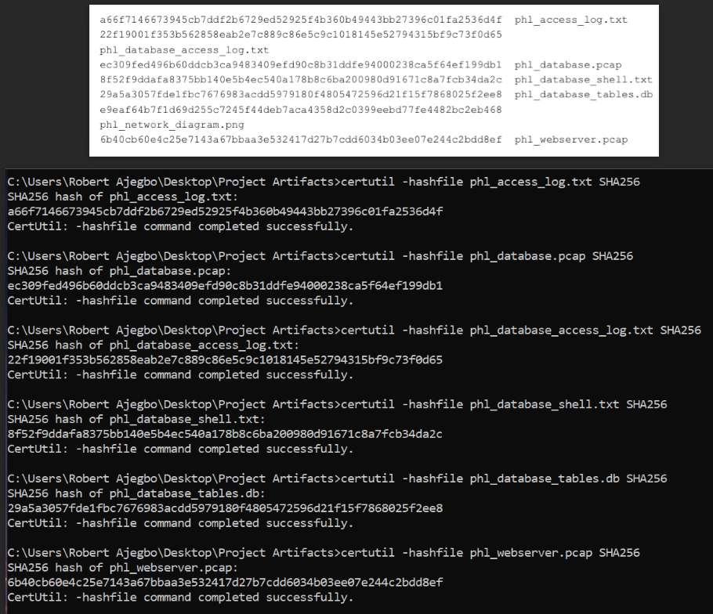
Attacker Reconnaissance:
In the Access Log, we can see some HTTP GET Requests from the attackers using SiteCheckerBotCrawler to seek information about specific web pages.
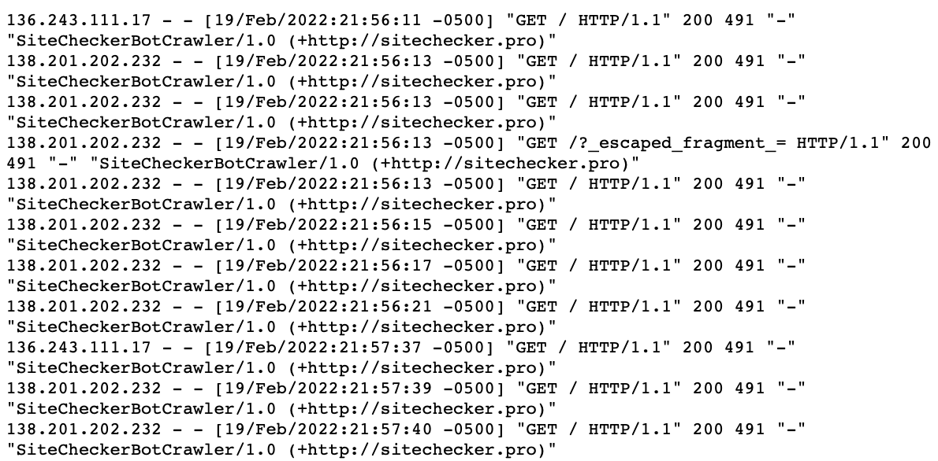
Access Log Requests:
Deeper into the access log, we can see that the hackers are trying to gain access to the server to run malicious code but they are met with the HTTP 404 error code. Eventually, they successfully request data through the GET command for an upload file. They are met with an HTTP 200 OK code following the request and they can run a POST command to gain remote access to the web server. (HTTP or Hypertext Transfer Protocol is the standard protocol for transmitting data over the internet.)
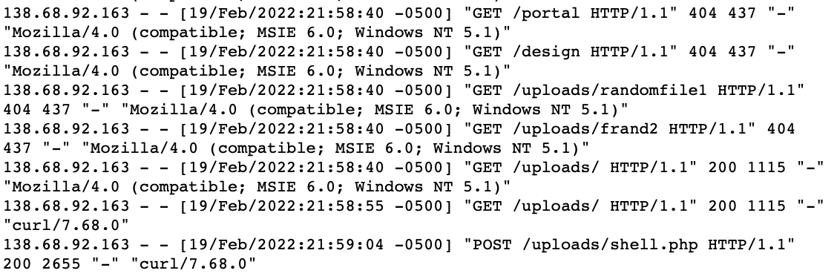
Initial three-way handshake established [SYN] [SYN, ACK] [ACK]
A three-way handshake is established between the server and the suspected attacker on an unknown IP address (138.68.92.163). This is the standard method for creating a TCP connection between two devices and thus, allowing the intruders to communicate with the web server. Below, you can see a screen capture of the three-way handshake within the web server packet capture on Wireshark.
Network map (Nmap) Scan:
The attackers run an Nmap scan on the network. This scan allowed them to identify hosts on a target network and scan for open ports. These open ports can be used as a backdoor entry to gain access to the hosts. Below, you can see a screen capture of the Nmap scan used by the hackers to map out the Premium House Lights network.
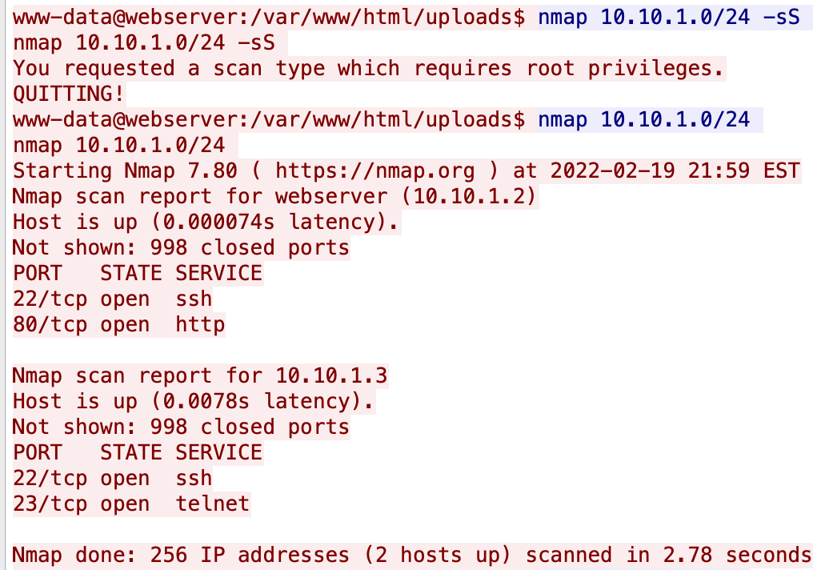
SQL Injection:
Below, you will see how the attackers deployed a SQL injection technique to compromise the system and replicate the original database.
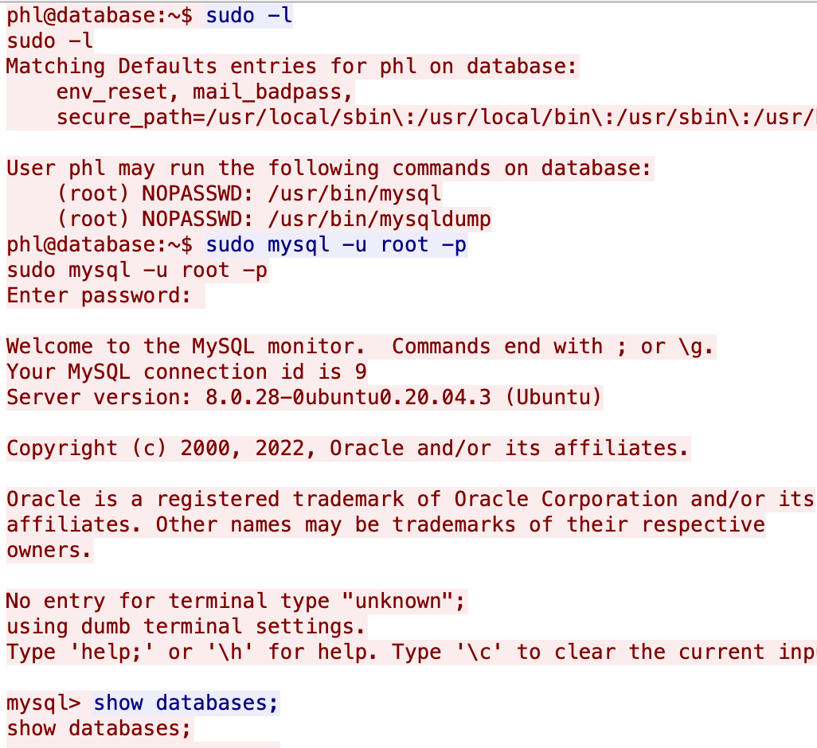

Database Exfiltration:
In the following screen capture, you can see exactly how the attackers exfiltrated the stolen database. They used an SCP (secure copy protocol) command to transfer the phl.db file to another unknown destination host of 178.62.228.28. Following the successful exfiltration, they removed the copied database file from the database to try and cover their tracks.
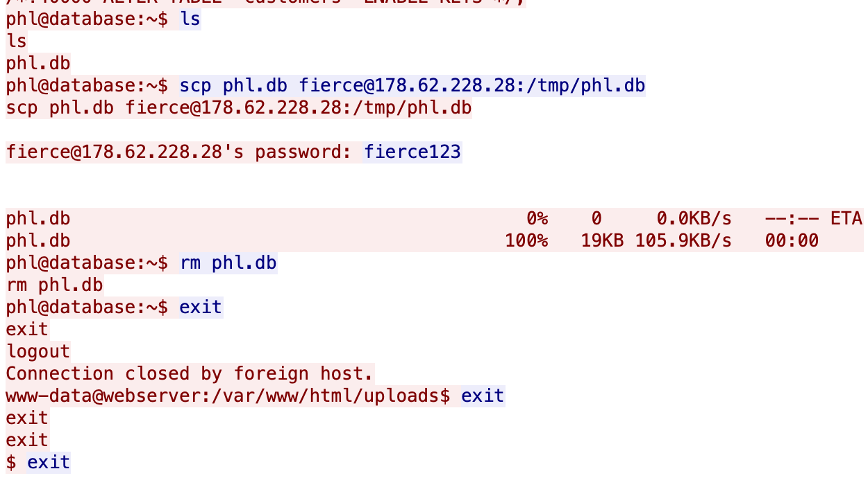

Incident Response:
Following these reactive measures outlined by the NIST Cybersecurity Framework; will ensure that the incident is addressed thoroughly and effectively:
- Containment:
  - Isolate and contain affected systems to prevent further unauthorized access
  - Change access credentials, and lock down compromised accounts
  - Apply any available security patches to address vulnerabilities
- Eradication:
  - Determine the root cause of the breach and eliminate the threat
- Recovery:
  - Restore affected systems from clean backups to bring them to a secure state
- Communication and Coordination:
  - Notify affected customers promptly, providing clear and concise information to provide full transparency
  - Coordinate with stakeholders to ensure a cohesive response
    - Learn from this incident to prevent future incidents

Post-Incident Recommendations:
As stated above, the best way to fully recover from a cyber incident like this is to take some learning from it. You must now implement proactive measures to enhance the overall security landscape and try to prevent future breaches. The following security measures align with the NIST Framework and improve your overall security infrastructure:
- Implement Multi-Factor Authentication (MFA):
  - MFA should be enforced as it enhances security by requiring multiple forms of authentication and it helps protect against unauthorized access
- Network Segmentation:
  - The network layout should be changed so that critical systems are isolated from less secure areas of the network. You should also consider implementing firewalls to filter out unwanted attention and prevent unauthorized access.
- Data Encryption and Access Controls:
  - All sensitive data and private information should be secured through encryption to prevent hackers from accessing it even if they breach the network. You should also implement strict access controls such as Role-Based access control where the employees only have the minimum access needed to complete their tasks.
- Security Awareness Training:
  - All employees must understand the importance of protecting sensitive customer data. They should be educated and made aware of common threats, best practices, and how to recognize and report suspicious activity (or at least what potentially could be suspicious).
- Consider hiring a Cyber Security Team:
  - They can help with conducting security assessments and penetration testing to identify vulnerabilities
  - They can also help with continuous monitoring to help prevent future attacks

References
(n.d.). MITRE ATT&CK®. Retrieved September 12, 2023, from https://attack.mitre.org
Computer Security Incident Handling Guide. (n.d.). NIST Technical Series Publications. Retrieved September 12, 2023, from https://nvlpubs.nist.gov/nistpubs/specialpublications/nist.sp.800-61r2.pdf
Cybersecurity Framework | NIST. (n.d.). National Institute of Standards and Technology. Retrieved September 12, 2023, from https://www.nist.gov/cyberframework
Froehlich, A. (n.d.). How to Prevent a Data Breach: 10 Best Practices and Tactics. TechTarget. Retrieved September 12, 2023, from https://www.techtarget.com/searchsecurity/tip/How-to-prevent-a-data-breach-10-best-practices-and-tactics
Threat Scenario. (2022, August 30). LHL Compass. Retrieved September 11, 2023, from https://cyber.compass.lighthouselabs.ca/p/2/days/w11d3/activities/3186
What is a web crawler? | How web spiders work. (n.d.). Cloudflare. Retrieved September 12, 2023, from https://www.cloudflare.com/en-ca/learning/bots/what-is-a-web-crawler/
What is TCP 3 Way Handshake? (n.d.). Scaler. Retrieved September 12, 2023, from https://www.scaler.com/topics/computer-network/tcp-3-way-handshake/

